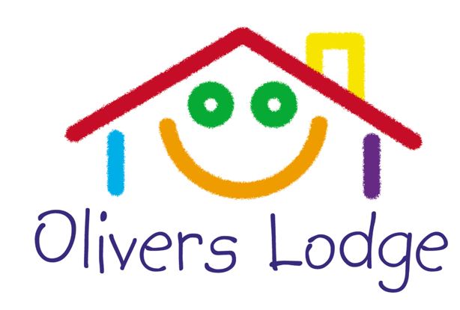

Enrolment Form

Your child
Name of child
Preferred name
Childs date of birth
Address (including postcode)
Collection Password

Parent 1
Name
Address (including postcode)
Work
Home
Mobile
Email
Parental Responsibility | Yes No

Parent 2
Name
Address (including postcode)
Work
Home
Mobile
Email
Parental Responsibility | Yes No

Olivers Lodge Limited: Tallards, High Street, Newport, Saffron Walden, Essex, CB11 3PQ
Telephone 01799 540709 Email me info@olivers-lodge.co.uk
Registered in England No. 04544711 Registered office as above

Guardian/Carer (if applicable)
Name
Address (including postcode)
Work
Home
Mobile
Email
Parental Responsibility | Yes No

Emergency contact
Name
Address (including postcode)
Work
Home
Mobile
Email

Medical Information

Details of professionals involved in your child’s care

Doctor
Name
Address (including postcode)
Telephone number

Social Worker (If applicable)
Name
Address (including postcode)
Telephone number

Health Visitor (If applicable)
Name
Address (including postcode)
Telephone number

Any other professionals involved in your child’s care
Name
Address (including postcode)
Telephone number

Is your child allergic to any form of medication?  If yes, please give details | Yes  No
Is your child allergic to any foods?  If yes, please give details | Yes  No

Is there anything we should know about your child's medical condition?  If yes, please give details | Yes  No
Should your child require emergency treatment and/or advice, do you give your consent? | Yes  No
Can your child use hypoallergenic plasters? | Yes  No
Which Language is spoken at home?

If English is not your child’s first language will this be your child’s first experience in an English speaking environment?

Individual Care Plan
Should your child have any specific or individual needs; medical or not. Please make notes on how you would like us to meet the needs for your child.

Home Time

Name and address of people authorised to collect your child*
Name
Address (including postcode)
Telephone number

Name
Address (including postcode)
Telephone number

Name
Address (including postcode)
Telephone number

Name and address of people NOT authorised to collect your child/children*
Name
Address (including postcode)
Telephone number

Name
Address (including postcode)
Telephone number

Name
Address (including postcode)
Telephone number

Medication
Do hereby give any of the staff within Olivers Lodge, with a suitability check, of the above named child, my permission to administer medication listed below (previously agreed with the parent/guardian).

Date | Medicine | Dosage | Time of last dosage | Time taken | Staff Signature | Parent Signature

Permissions
Do hereby give any member of Olivers Lodge with a suitability check permission for the following outlined below:
Yes | No
 |  | Permission to use their car; reasons for use of staff cars may be to collect children from school and emergency usage.
 |  | Permission in an emergency to seek urgent medical attention should the need arise, including a trip to hospital.
 |  | Permission to take photographs of my child.
 |  | Permission for the photos to be uploaded on FaceBook.
 |  | Permission for any photos taken to be published in the local newspapers.
 |  | Permission to use the mini bus/or car, for outings or emergency treatment.
 |  | Permission for children to move between Olivers Lodge registered provisions.
 |  | Head Lice: I agree to adhere to the policies regarding head lice within Olivers Lodge.
 |  | Use face paints.
 |  | Permission to use photographs of your child on the Olivers Lodge web site
 |  | Helping to apply sun cream
 |  | Hugs
 |  | Nuts (traces and/or derivatives of)
 |  | Permission for my child’s name to be displayed within the setting i.e coat pegs, birthday wall
 |  | Permission for Oliver’s Lodge to use mine and my child’s details to apply for funding on the secure government website
 |  | Permission for Olivers Lodge to use my child’s details and pictures on secure forums such as tapestry to track learning and development where applicable
 |  | Permission for Olivers Lodge to keep my child’s details on a secure password protected server as well as locked in a secure cabinet on site
 |  | Permission for Olivers Lodge to share my child’s details with other health professionals i.e speech and language, Area SENCO

Terms and Conditions

If my child is not attending, I need to ring the main number to inform Olivers Lodge of none attendance. 01799 540709.
A month’s written notice to hannah@olivers-lodge.co.uk is required to cancel your child’s place in Olivers Lodge.
Payments for afterschool and breakfast clubs need to be made by Standing Order on or just after the 1st of the month.
Account name: Olivers Lodge
Account number: 17510384 Sort Code: 60 24 77
There are no refunds for cancelled sessions.
There are no refunds if your child is booked on a regular basis and attends a residential trip with school.
There are no refunds if the school closes and as a result we cannot open (eg: snow days and other adverse weather conditions).
Holiday schemes are paid for in full, prior to the scheme starting.
A late payment charge will be invoiced if the payment is later than the 5th of the month.
Over payment via vouchers will not be refunded.
There are no refunds less than 30 days before a holiday scheme is due to start. This is due to the fact the staff will all have been allocated their rota based on numbers and ratios; hence they will expect to be paid.
I understand prices will be reviewed and increased at the start of every school year.
I understand that if I fail to pay the fees, I am putting my child’s place and it may be withdrawn.
I understand if I am up to 15 minutes late collecting my child/ren, there will be a £5.00 late payment fee, thereafter the fee increases be an additional £5.00 per five minutes.
Olivers Lodge is not responsible for any of the child’s personal possessions or valuables while they attend the club.
It is your responsibility to keep us updates with any changes to the information supplied above.

I have read and understood all the above.
Signature (type name or import signature)
Print name
Relationship to the child
Date

